CLIMATE CHANGE:

Shishmaref, Alaska – The Sinking Village and its Community Impacts

INTRODUCTION
Shishmaref is an Inupiat Eskimo community on an island in the far northwest corner of Alaska. Their native land is threatened by the sea as a result of global warming. During October 1997, a severe storm eroded over 30 feet of the north shore, requiring 14 homes and the National Guard Armory to be relocated. Five additional homes were relocated in 2002. While the storms have continued to erode the shoreline an average of three to five feet per year on the north shore, residents in July 2002 voted to relocate the community⁽¹⁾.
The 573 inhabitants (as estimated on the 15th june, 2012) will be forced to relocate to the mainland within ten years ⁽¹⁾ making the people of Shishmaref the first refugees of global warming as described by the BBC news in an online article about the sinking village of Shishmaref ⁽²⁾
*****
Location and Demographics
Shishmaref is located on Sarichef Island, in the Chukchi Sea, just north of the Bering Strait (Picture1). It is 5 miles from the mainland. The village is surrounded by the 2.6 million-acre Bering Land Bridge National Reserve. It is part of the Beringian National Heritage Park, endorsed by Presidents Bush and Gorbachev in 1990. The community lies at approximately 66.256670° North Latitude and -166.071940° West Longitude. Shishmaref is part of the Cape Nome Recording District. The area encompasses 2.8 sq. miles of land and 4.5 sq. miles of water.
The area experiences a transitional climate between the frozen Arctic and the continental Interior. Summers can be foggy, with average temperatures ranging from 47 to 54 °F; winter temperatures average -12 to 2 °F. Average annual precipitation is about 8 inches, with 33 inches of snow. The Chukchi Sea is frozen from mid-November through mid-June.
The tribe located in the traditional village is federally-recognized and encompasses a fishing and subsistence lifestyle.
Picture 1.
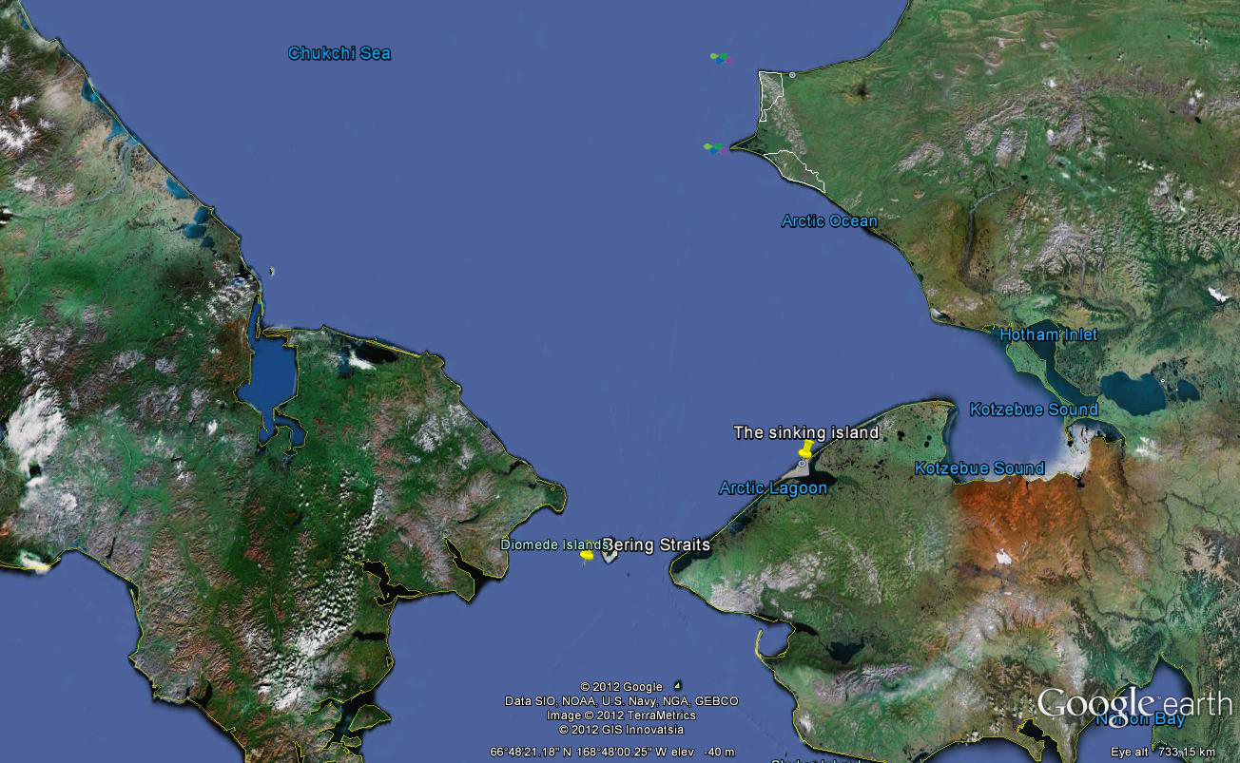
Source: Google Earth ⁽³⁾

Due to the global warming, Shishmaref village colonized for 400 years is now facing evacuation. These rising temperatures are causing a reduction in sea ice, thawing in this way the permafrost along the coast ⁽⁴⁾. Figure 1 displays a warming trend over the past century as recorded in Alaska's interior boreal forest ⁽⁶⁾. As a consequence, less sea ice and more open water has turned storms into being destructive to the coastline inducing the melting of permafrost making the shoreline more vulnerable to erosion. In addition, the inhabitants’ homes, water system and infrastructure are being damaged ⁽⁴⁾ ⁽⁵⁾. Erosion has increased in many other villages apart from Shishmaref, threatening houses and perhaps the entire community. Wave action has changed some sandy beaches into rocky ones, as the sand washes away. There have been no new sandy beaches, but there are many new rocky ones ⁽⁴⁾.
Figure 1.
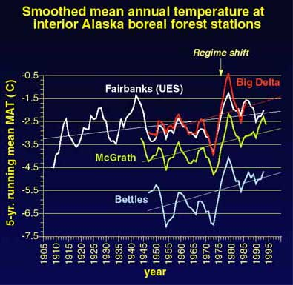
Sarichef Island (on which Shishmaref is located), is part of a dynamic 100km-long barrier island chain that records human and environmental history spanning the past 2000 years. However, erosion at Shishmaref is rather unique along the islands due to three reasons: (a) its fetch exposure and high tidal prism, (b) relatively intense infrastructure development during the 20th century and (c) because of multiple shoreline defence structures placed since the 1970s. Erosion rates along the island front exceed (and are not comparable with) those along adjacent sectors. Erosion is observed along the entire island chain – it is nevertheless aggravated at Sarichef Island in part because of the infrastructure which accelerates permafrost degradation and due to hydrographic impacts of hard armouring of a sandy shorefront. Residents are experiencing the effects of coastal retreat on their residential and commercial properties while in the meantime there is a need to develop solutions, potentially including the difficult choice of abandoning the island⁽⁴⁾. Erosion is only one of Shishmaref's many concerns. The warming climate and erosion threaten to steal the centuries-old culture, their unique language and the viability of their entire village.

What are the additional challenges these communities are experiencing due to climate change? Since the late 1970s, Alaska Natives in communities along the coast of the northern Bering and Chukchi Seas have noticed substantial changes in many environmental factors including the ocean and the animals that live there: trends observed from year-to-year in weather, hunting conditions, ice patterns, and animal populations. If these trends continue, major and perhaps irreversible impacts in such communities should be expected.
Beginning in the late 1970s, the patterns of wind, temperature, ice, and currents in the northern Bering and Chukchi Seas have changed with stronger winds –commonly 15-25 mph, and fewer calm days. The wind may shift in direction, but remains strong for long periods. In spring, the combination of wind change and warm temperatures, impacts the distribution of the sea ice and speeds up the melting of ice and snow. As an effect of the ice melting or moving away early, many marine mammals leave with it, taking them far away to hunt. In some villages –including Shishmaref, the wind may push the pack ice towards the shore, making it impermeable to float boats in open water for hunting or to move boats through if they are already out. The packed ice problem depends on the geography of the coast. Moreover, the high winds also make it difficult to travel in boats for hunting (even winds of 10–12 mph from the wrong direction can create waves 2–3 feet high, stopping small boats), restricting in this way the number of days that hunters can go out ⁽⁵⁾. Alaskan Native subsistence hunters depend on their traditional knowledge of sea ice extent and thickness during the hunting season. Taking all these effects into account, on one hand access to animals during the spring hunting period is lower now than it was before. On the other hand, with changing climate conditions, sea-ice conditions are less predictable and pose a serious public safety risk as well as threatening indigenous lifestyles ⁽⁶⁾.
Furthermore, precipitation patterns have also changed. In the last two years, there has been substantial snowfall in late winter and early spring but little snow in fall and most of the winter. In the winter of 1998–99, the weather was cold so that the ice was thick, but there was no snow. The lack of snow makes it difficult for polar bears and ringed seals to make nests for giving birth or, in the case of male polar bears, to seek protection from the weather. The lack of ringed seal dens may affect the numbers and condition of polar bears, which prey upon ringed seals and often seek out the dens. Hence, hungry polar bears may be more likely to approach villages and encounter people ⁽⁵⁾
Arctic Alaska acts as an indicator for many significant environmental changes over time. Such changes are not regarded as irregularities from a remote area. They are imposing severe threats on the lives of residents of northern Alaska –Natives pursuing traditional ways of life deeply rooted in the local environment. The changes seen in the Arctic are just the beginning, they are the early precursors of changes in climate that are likely to affect much of the world in the several decades to come. The impacts to Arctic residents and the lessons those impacts have for the rest of the country and the world, are ignored in our expense. It is clear that more attention is needed to assess the risks that we face and to identify actions that can be taken to minimize those risks.
REFERENCES:
- Alaska Community Database Community Information Summaries: Shismaref. Available at: http://commerce.alaska.gov/dca/commdb/CIS.cfm?Comm_Boro_Name=Shishmaref (Retrieved on: 19 June, 2012).
- BBC News, Sea engulfing Alaskan village. Available at: http://news.bbc.co.uk/1/hi/world/europe/3940399.stm Last Updated 30 July 2004, (Retrieved on: 27 June, 2012).
- Google Earth 6.2 program, downloaded from: http://www.google.com/earth/index.html Map of Shishmaref Village, Alaska (Retrieved on: 27 June, 2012)
- NOAA Arctic Website, Human and Economic Indicators – Shishmaref. Available at: http://www.arctic.noaa.gov/detect/human-shishmaref.shtml Last updated December 2006, (Retrieved on: 20 June, 2012).
- NOAA Arctic Website, How have changes in Arctic environment over the past 50 years affected the Alaska Native community? Native observations of change in the marine environment of the Bering Strait region. Available at: http://www.arctic.noaa.gov/essay_pungowiyi.html (Retrieved on: 20 June, 2012).
- NOAA Research Website, Enhancing Decision-Making Through Integrated Climate Research: Alaska Region Meeting. Available at: http://www.oar.noaa.gov/spotlite/archive/spot_risa_ak.html Last updated 25 June 2012, (Retrieved on: 27 June, 2012).

